Geashill (GHLB)
Monday 16 March 2026
13:24
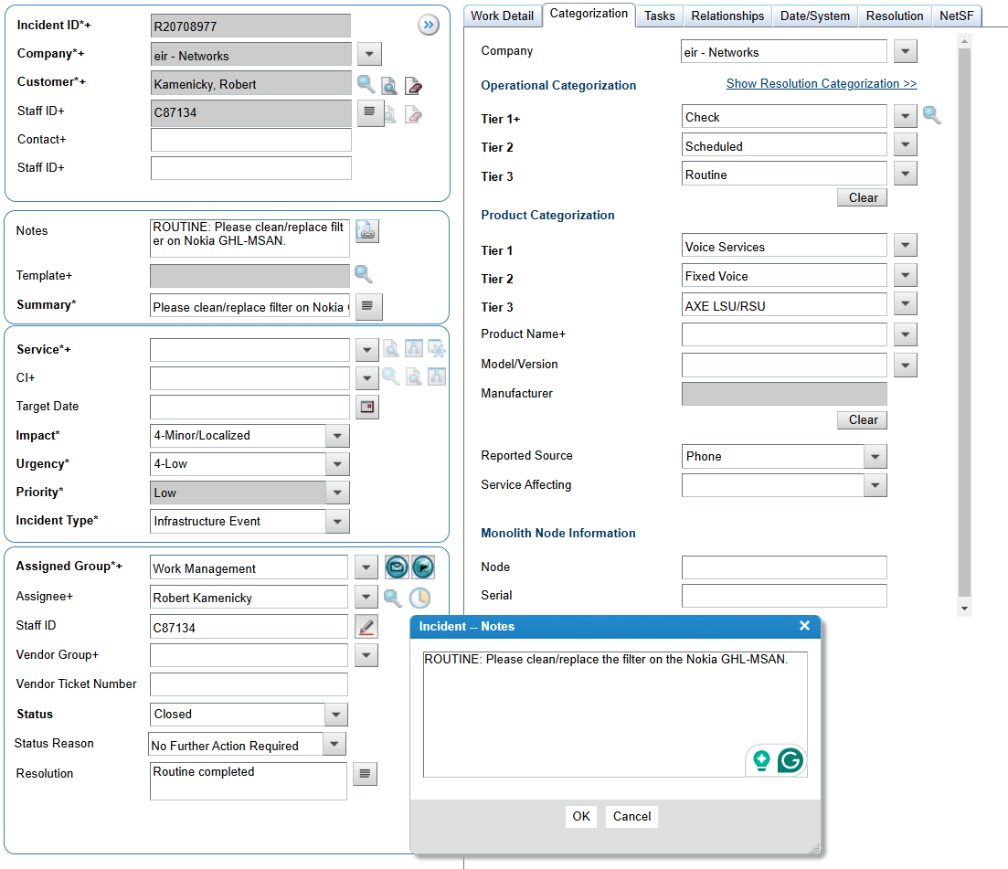

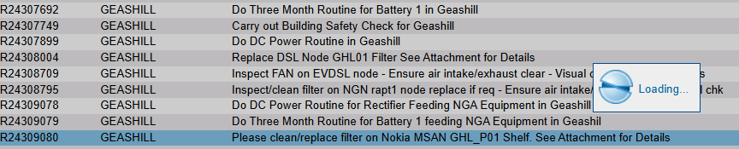

+ MSAN
Please clean/replace the filter on the Nokia GHL-MSAN.

Overall Voltage: 54.26V

1 | 2 | 3 | 4 | 5 | 6 | 7 | 8 | 9 | 10 | 11 | 12 | 13 | 14 | 15 | 16 | 17 | 18 | 19 | 20 | 21 | 22 | 23 | 24
2.19 | 2.2 | 2.27 | 2.26 | 2.11 | 2.16 | 2.21 | 2.27 | 2.26 | 2.26 | 2.27 | 2.15 | 2.14 | 2.26 | 2.26 | 2.29 | 2.41 | 2.19 | 2.28 | 2.26 | 2.27 | 2.33 | 2.33 | 2.29

DC Routines Powec (creamy) Power One

Rectifiers | 5
DC Power Load | 11.7
Boost Voltage | 54.2
Float Voltage | 54.18

Alarm Limits
Low Voltage | 47V
High Voltage | 58
High Load | 99%
High Temperature | 30 °C

Display on Powec 10.48 is unreadable, and cannot trigger alarms.

DC Routines Power One NGN

Rectifiers | 5
DC Power Load | 12
Boost Voltage | 56.4
Float Voltage | 54.2

Alarm Limits
Low Voltage | 47V
High Voltage | 58
High Load | 80%
High Temperature | 28°C
Temp: 14

Overall Voltage: 54.77V
1 | 2 | 3 | 4
13.76 | 13.71 | 13.62 | 13.65

Low Voltage and High Temperature alarms were tested, but SMC only detected the "Rectifiers fail" alarm.

Low Voltage and High Temperature alarms were tested, but SMC only detected the "Rectifiers fail" alarm.

Rahan (RANB)
12 March 2026
13:17

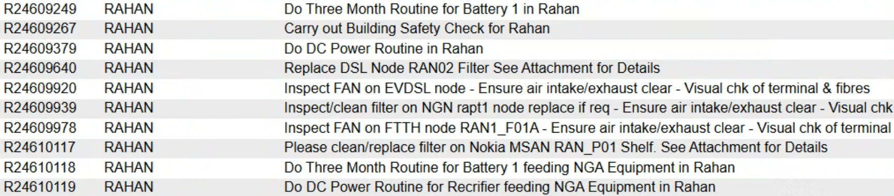

Do Three Month Routine for Battery 1 in Rahan

Overall Voltage: 54.08
Temperature: 18 C
Cell | 1 | 2 | 3 | 4 | 5 | 6 | 7 | 8 | 9 | 10 | 11 | 12 | 13 | 14 | 15 | 16 | 17 | 18 | 19 | 20 | 21 | 22 | 23 | 24
Voltage | 2.3 | 2.29 | 2.29 | 2.19 | 2.28 | 2.21 | 2.23 | 2.29 | 2.2 | 2.27 | 2.24 | 2.2 | 2.21 | 2.29 | 2.29 | 2.29 | 2.28 | 2.2 | 2.28 | 2.22 | 2.27 | 2.27 | 2.19 | 2.28

Do DC Power Routine in Rahan

Rectifiers: 6
DC Load: 17.6 A
Boost Voltage: 54.1
Float Voltage: 54.96

Low Voltage: 47
High Voltage: 58
High Load 80%
High Temperature: 28 C

Low Voltage, High Voltage, High Load, and alarms were tested, but only 2 alarms were detected — external rectifiers alarms.

Temperature alarm is not wired.

─────────────────────────────────────────────────────────────────────────────────────────
Aidan.moynihan@eir.ie created 3 new routines

Do Three Month Routine for Battery 1 in Rahan feeding NGA

Overall Voltage: 53.94

Cell Number | 1 | 2 | 3 | 4
Voltage | 13.57 | 13.54 | 13.54 | 13.57

Do DC Power Routine in Rahan feeding NGA

Rectifiers: 5
DC Load: 6A
Boost Voltage: 54.5
Float Voltage: 54.24

Low Voltage: 47
High Voltage: 58
High Load 80%
High Temperature: 30 C

Low Voltage, High Voltage, High Load, and High Temperature alarms were tested, but only one alarm was detected — external rectifiers alarm

─────────────────────────────────────────────────────────────────────────────────────────

